Introduction
An open-source tool called VirusTotal will be manually used to analyze suspicious email and malicious PDF attachment. These tools will identify and report any malware pattern found in the attached file https://wilsescybersecurity.com/sensitive/
VirusTotal is an online open-source tool used for analyzing suspicious URL and files (PDF, Word, etc.) with intent to detect malware. Antivirus engines and website scanners are used to check for malicious content.
Sender Analysis:
The first sender analysis
From the analysis shown from VirusTotal, The URL is not flagged malicious and there is no malware found on the files and email, these files are clean and unread from malware infections.
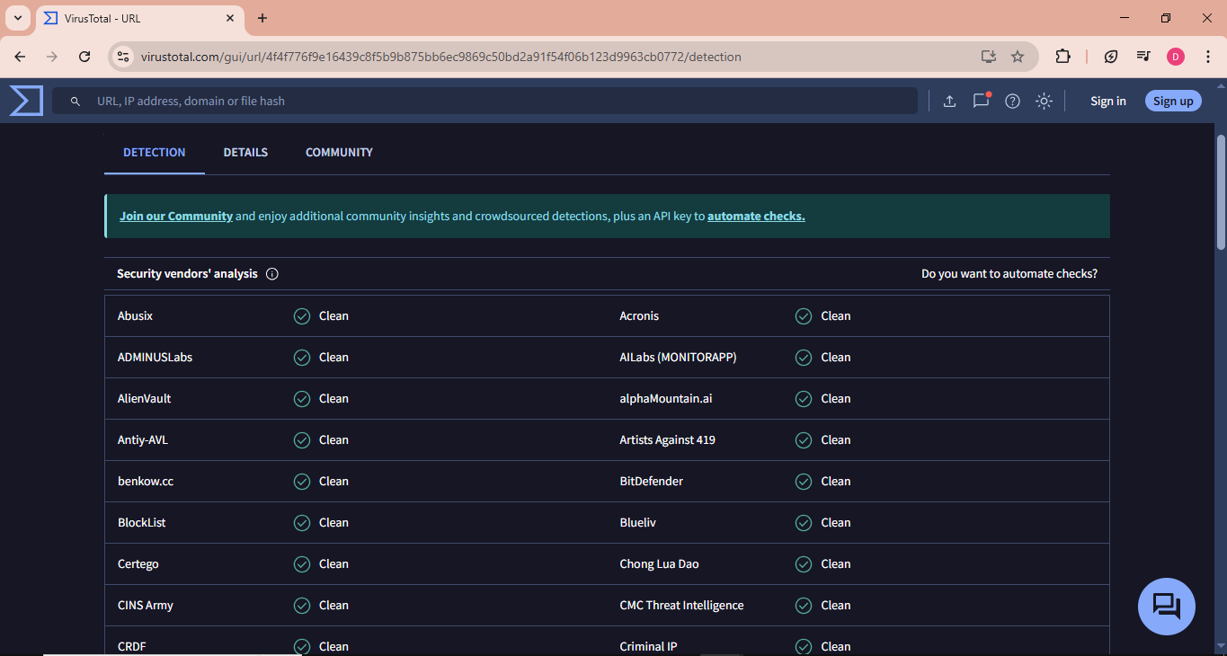
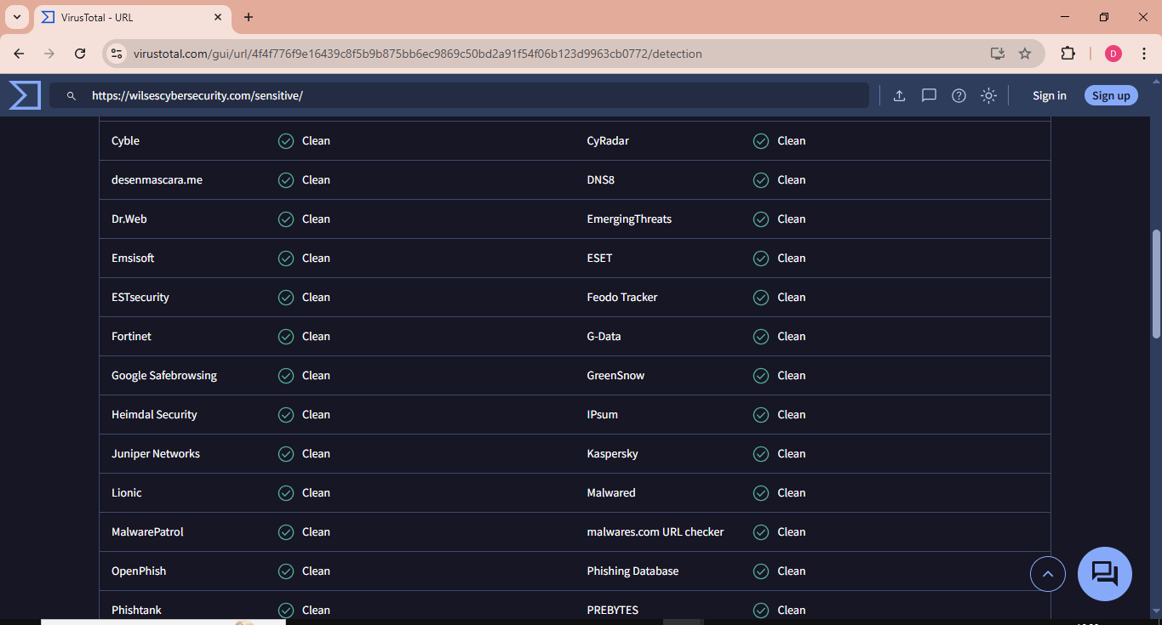

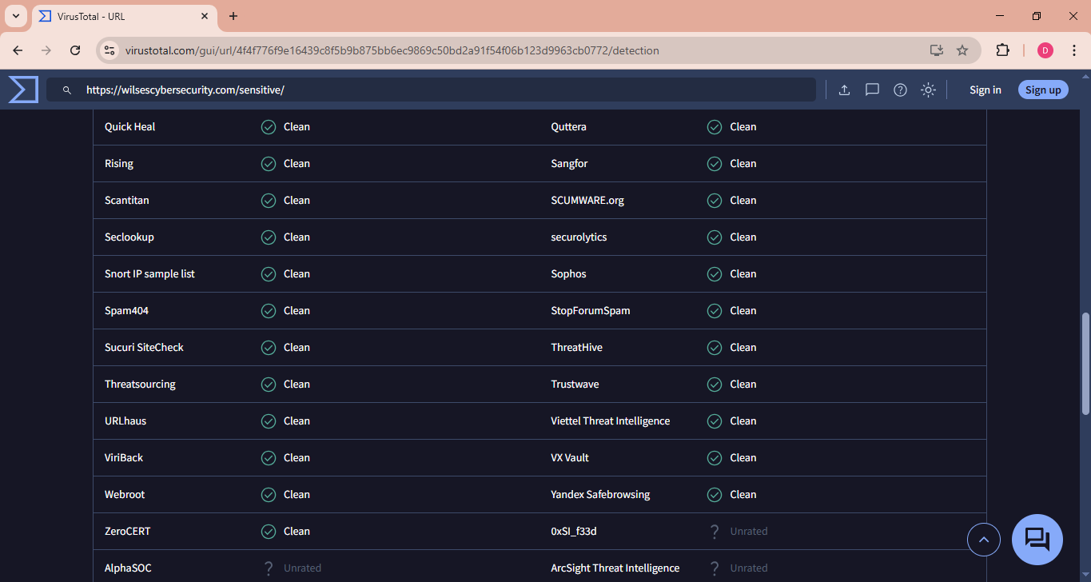
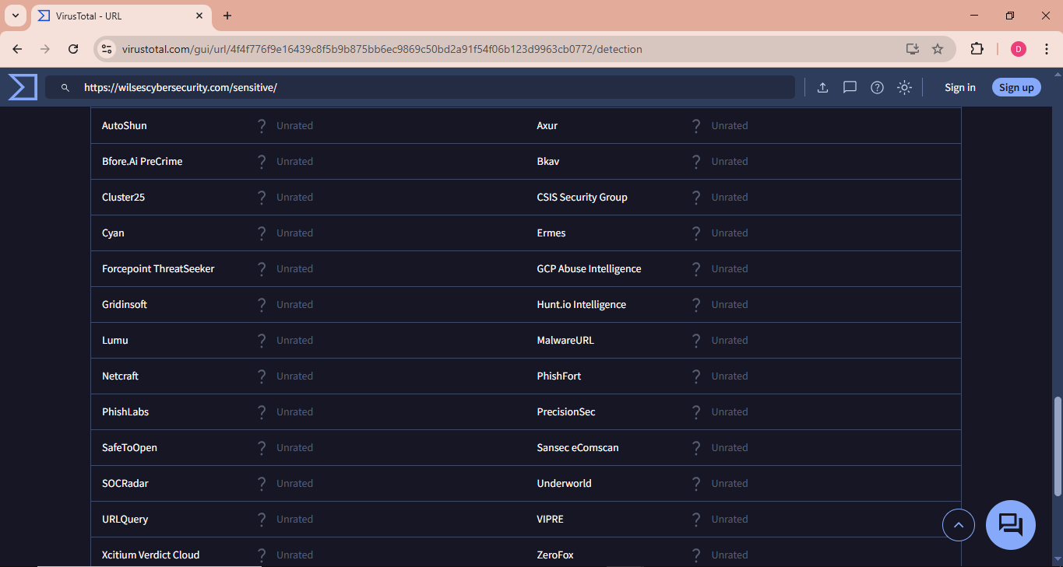

The analysis was done again and as shown below. The current analysis shows that CRDF file is malicious and Fortinet is Phishing.

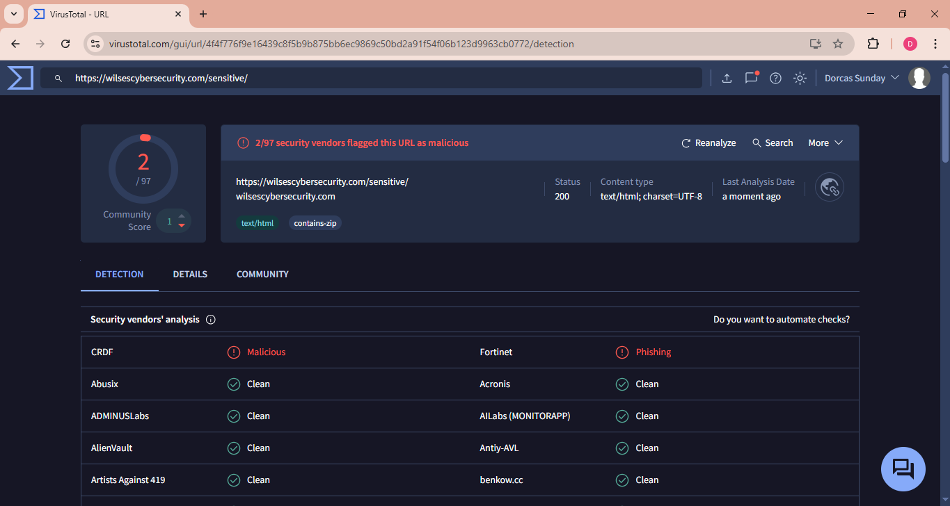
ESMTP/Server Details:
Server name is LiteSpeed. The IP address is 46.28.45.252, the URL has an integrity check file which could be seen under Body SHA-256. The status code is 200, the content type is text/html. The connection is ‘Keep-Alive’

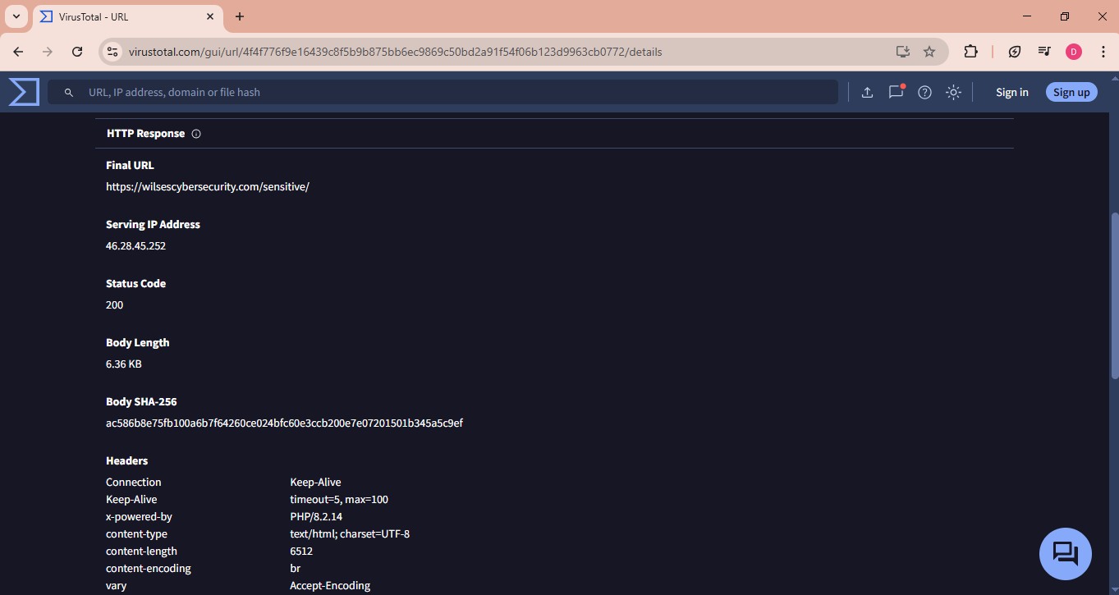

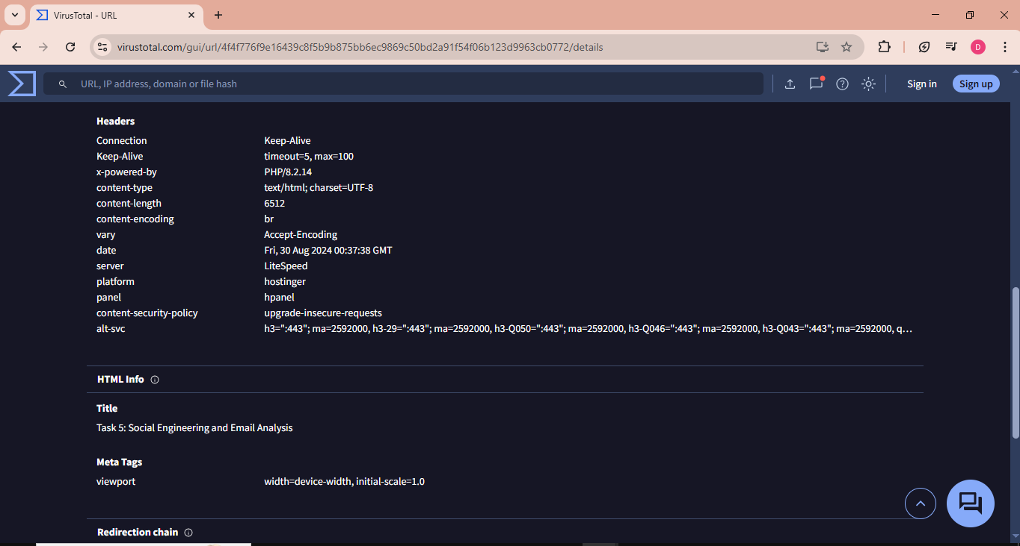
Location:
The location is hostinger.
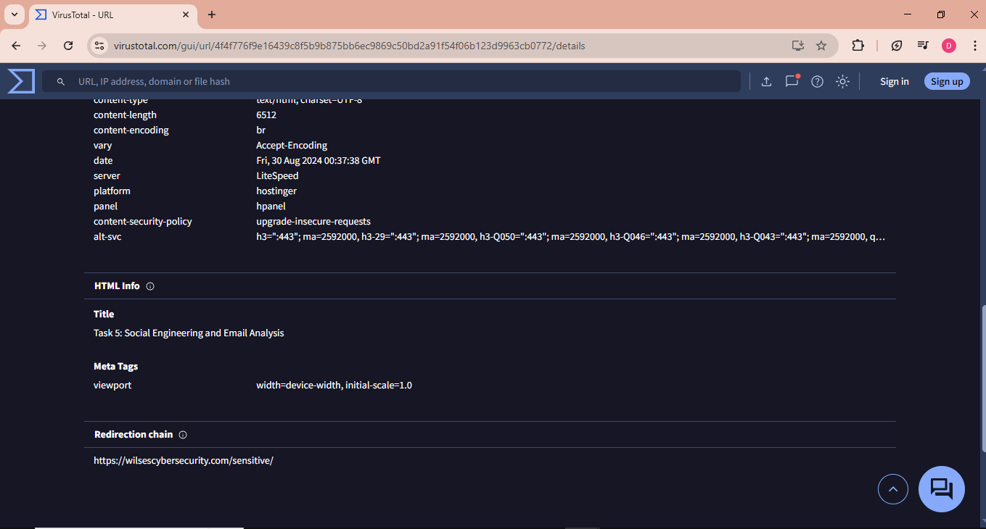

Time of Attack:
The attack occurred 9 months ago, 30-08-2024 at 00:37:35 UTC
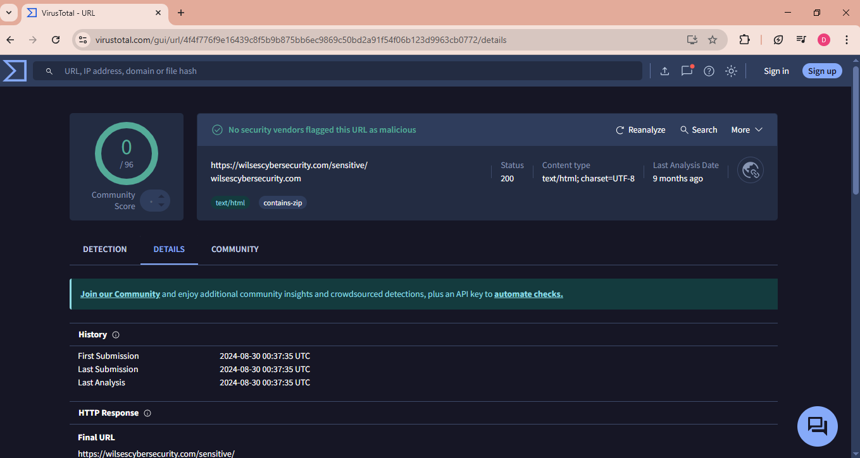
As at the time I conducted the second analysis the time was an hour behind WAT.
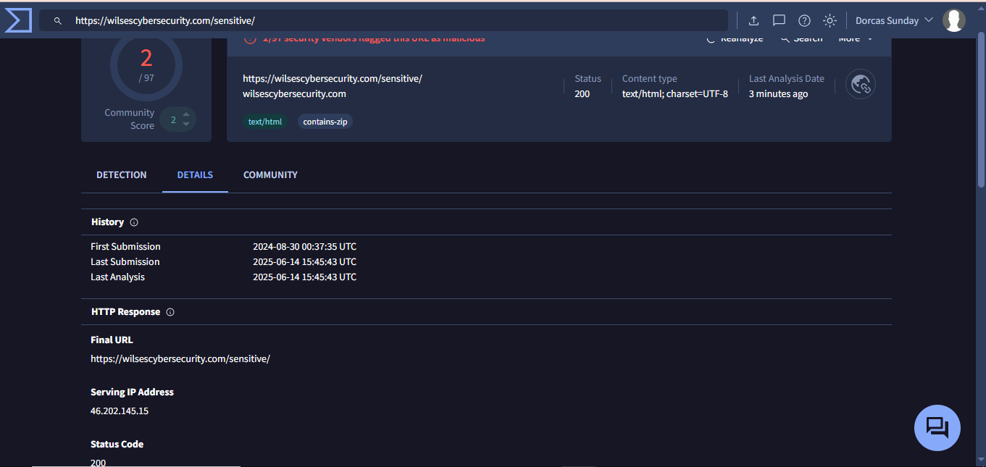
Mitigation
To resolve, users should not click links and attachments sent to them even from a reliable source so to prevent Phishing attack. Look out for mismatched URLs and grammatical errors. Use built in email client’s protection to filter incoming messages and block all images unless it is approved.
Data should be backed up regularly; antivirus software protection should be installed on work devices. Update software frequently. The use of strong password should be incorporated. Implement least privilege methodology to prevent user’s access control and allow users to only have access to software and data required to complete their task. Ensure to use network segmentation as it divides your network into smaller parts.
Conclusion
In summary, files should be encrypted properly and the above mitigation should be implored to secure the data, system and network from cyber criminals.

